Supplemental Materials: Associations of Phenols and Parabens with Anti-Müllerian Hormone During the Menopuase Transition: The Study of Women’s Health Across the Nation
Wenzhiyuan Zhang¹, Jiaxin Wu¹, Ellen B. Gold², John F. Randolph Jr.³, Sioban Harlow¹, Nanette Santoro,⁴ Samar R. El Khoudary⁵, Sung Kyun Park^{1,6}
1. Department of Epidemiology, School of Public Health, University of Michigan, MI, USA
2. Department of Public Health Sciences, University of California, Davis School of
Medicine, CA, USA
3. Department of Obstetrics and Gynecology, School of Medicine, University of Michigan, MI, USA
4. Department of Obstetrics and Gynecology, School of Medicine, University of Colorado, CO, USA
5. Department of Epidemiology, School of Public Health, University of Pittsburgh, PA, USA
6. Department of Environmental Health Sciences, School of Public Health, University of
Michigan, MI, USA

Correspondence:
Sung Kyun Park, ScD, MPH, Departments of Epidemiology and Environmental Health Sciences, University of Michigan, School of Public Health, 1415 Washington Heights, Ann Arbor, MI 48109-2029, Phone: (734) 936-1719, Fax: (734)936-2084, E-mail: sungkyun@umich.edu
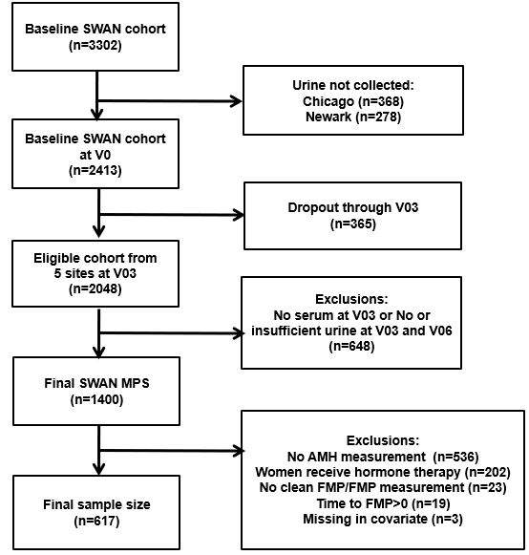
Figure S1. Final Analytic Sample Flowchart.

Phenol | Tertile 1  (95% CIs) | Tertile 2  (95% CIs) | Tertile 3  (95% CIs) | P value for trend | Percent changes  (95% CIs) | P value
bisphenol A | Ref | 13.56% (-4.55–35.11) | 5.98% (-11.29–26.61) | 0.53 | 2.69% (-2.38–8.03) | 0.30
bisphenol F | Ref | 1.55% (-14.62–20.79) | 15.30% (-3.59–37.89) | 0.12 | 0.75% (-4.08–5.82) | 0.77
2,4-diclorophenol | Ref | 6.49% (-10.83–27.16) | 16.16% (-4.08–40.68) | 0.13 | 3.54% (-0.21–7.44) | 0.07
2,5-diclorophenol | Ref | -16.61% (-30.60–0.19) | -1.82% (-20.77–21.67) | 0.78 | 1.37% (-1.97–4.83) | 0.43
Triclosan | Ref | 18.26% (-0.95–41.19) | 17.29% (-2.23–40.70) | 0.09 | 2.04% (-0.98–5.16) | 0.19
Methyl-paraben | Ref | -5.07% (-20.61–13.51) | -10.52% (-26.55–9.02) | 0.27 | -1.33% (-4.92–2.41) | 0.48
Ethyl-paraben | Ref | -15.32% (-29.01–1.01) | -17.46% (-31.69–-0.27) | 0.044 | -3.93% (-6.90–-0.86) | 0.013
Propyl-paraben | Ref | 7.46% (-10.06–28.41) | -5.68% (-21.93–13.95) | 0.53 | -1.00% (-3.74–1.82) | 0.48
Butyl-paraben | Ref | -18.26% (-31.71–-2.17) | -9.88% (-25.43–8.91) | 0.28 | -1.88% (-4.77–1.10) | 0.21
Benzophenone-3 | Ref | 12.13% (-6.65–34.70) | 7.23% (-12.51–31.42) | 0.51 | -0.13% (-2.54–2.34) | 0.92
Table S1. Percent changes (95% CIs) in AMH concentrations for a doubling in urinary phenol concentrations and by tertiles from multivariable linear mixed models.

Model were adjusted for age at the FMP, race/ethnicity, study site, education, smoking status, parity at baseline, BMI and time to the FMP.
All phenols were covariate adjusted creatinine standardized.
Abbreviations: AMH, anti-Mullerian hormone; BMI, body mass index; FMP, final menstrual period.
Table S2. Percent change (95% CI) in AMH concentrations per one-tertile increase in the urinary phenol mixture estimated using quantile g-computation.
Phenol | Percent changes  (95% CIs) | P value
Phenol Mixture | -1.61% (-24.7, 28.6) | 0.90

Model were adjusted for age at the FMP, race/ethnicity, study site, education, smoking status, parity at baseline, BMI at baseline and time to the FMP.
All phenols were covariate adjusted creatinine standardized.
The phenol mixtures include bisphenol A, bisphenol F, 2,4-dichlorophenol, 2,5-dichlorophenol, triclosan, methylparaben, ethylparaben, propylparaben, butylparaben, and benzophenone-3.
Abbreviations: AMH, anti-Mullerian hormone; BMI, body mass index; FMP, final menstrual period.

